Lift diverter
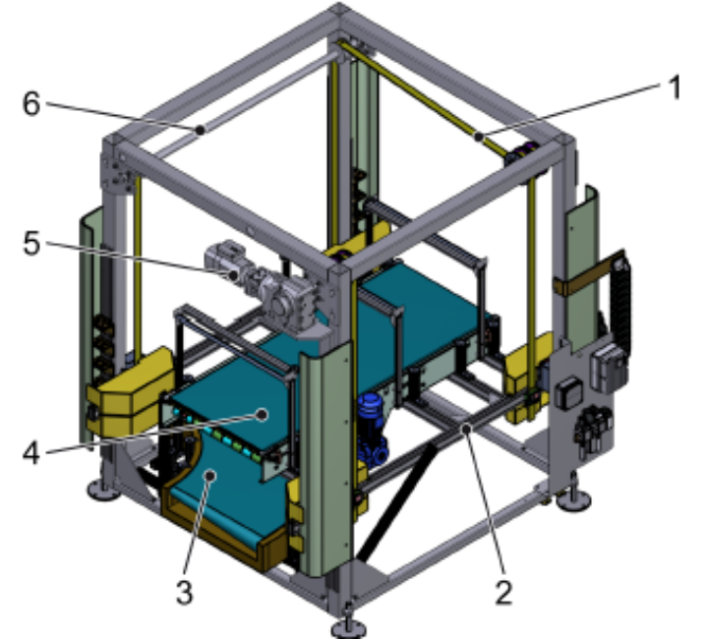
Layout

Figure Erro! Nenhum texto com o estilo especificado foi encontrado no documento.-25: 2-to-1 combiner

Figure 3-1: Lift diverter

Nº | Description
1 | Flat belt
2 | Lifting frame
3 | Transport segment 1
4 | Transport segment 2
5 | Drive
6 | Shaft

Function
The lift diverter is used to move the transport route for different transport lines.

